DEDUCE Simulated Operating Characteristics of Phase 1 Dose Escalation Designs

*Report Date and Time: “2021-05-20 16:20:31”*

*Software:* DEDUCE app version 1.0 available [here](https://bengarski.shinyapps.io/DEDUCE/)

# Objective:

To evaluate the operating characteristics of the following dose escalation design(s): **TARGET-CRM**

# Methods:

Trial operating characteristics are averaged over **100** simulated trials. Simulated trials have **5** dose levels labeled **1,2,3,4,5**, starting on dose level **2**, and assuming true toxicity probabilities of **0.05,0.12,0.2,0.25,0.4**. The target toxicity probability is **0.2**. One patient arrives every **30** days on average. The DLT observation period is **21** days.

For the TARGET-CRM and/or CRM design, the prior toxicity probabilities per dose level are **0.05,0.12,0.2,0.3,0.4**. The cohort size is **2** and the maximum sample size is **20**. Patients belong to one of two cohorts: Cohort A or Cohort B. Patients with pre-specified characteristics (e.g. tumor type, tumor mutation) belong to Cohort B; all other patients belong to Cohort A. The TARGET-CRM design allows enrollment of Cohort B patients at one dose level below the current dose during the DLT observation period of the current cohort of patients. The proportion of patients from Cohort B is **0.2**. Simulated trials using the TARGET-CRM and/or CRM designs are required to have a minimum enrollment of **0** Cohort B patients.

# Results:

**Accuracy:** For each dose level, Figure 1 presents the proportion of simulated trials that a given dose level was selected as the true MTD. The proportion of correct selection (PCS) of the MTD for the **TARGET-CRM** design is **0.32**.

**Safety:** Figure 2 presents the proportion of patients experiencing a DLT for each dose level. The proportion of patients experiencing a DLT for the **TARGET-CRM** design is **0.18** which is **lower** than the target toxicity probability of **0.2**

**Patient Allocation:** Figure 3 presents the proportion of patients assigned to each dose level. The proportion of patients assigned to the true MTD (dose level **3**) for the **TARGET-CRM** design is **0.28**.

**Study Duration:** Figure 4 presents the mean (+/- standard deviation) study duration in days for each design. The mean study duration for the **TARGET-CRM** design is **627.21** days (standard deviation = **24.59**).

Table 1 presents a summary of the operating characteristics for each design.

**Sample Size:** The mean total sample size for the **TARGET-CRM** design is **20** (range = **20**-**20**).

# Figures:

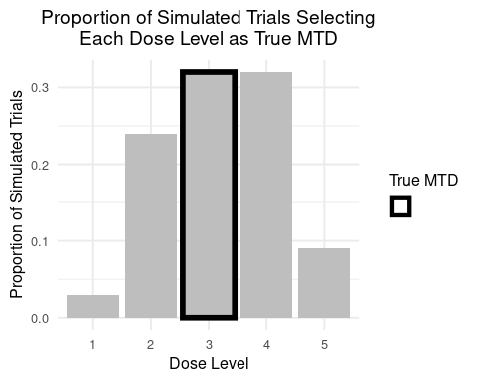

Figure 1: Proportion of simulated trials selecting each dose level as the true MTD.

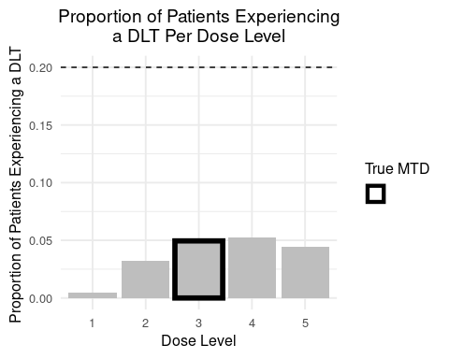

Figure 2: Proportion of patients experiencing a DLT per dose level. The target toxicity probability is denoted by the horizontal dashed line.

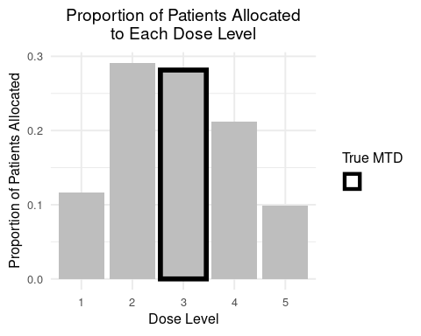

Figure 3: Proportion of simulated trials selecting each dose level as the true MTD.

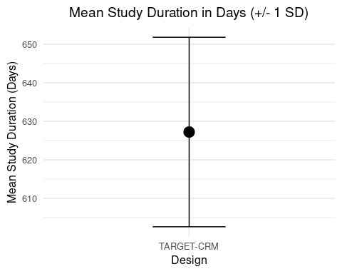

Figure 4: The mean (+/- 1 standard deviation) study duration in days.

Table 1: Summary of operating characteristics for the selected designs.

|  |  |
| --- | --- |
| Operating Characteristic | TARGET-CRM |
| Proportion of correct selection (PCS) | 0.320 |
| True MTD | 3.000 |
| Proportion of trials selecting dose 1 as true MTD | 0.030 |
| Proportion of trials selecting dose 2 as true MTD | 0.240 |
| Proportion of trials selecting dose 3 as true MTD | 0.320 |
| Proportion of trials selecting dose 4 as true MTD | 0.320 |
| Proportion of trials selecting dose 5 as true MTD | 0.090 |
| Proportion of patients experiencing a DLT overall | 0.184 |
| Proportion of patients experiencing a DLT at dose 1 | 0.005 |
| Proportion of patients experiencing a DLT at dose 2 | 0.032 |
| Proportion of patients experiencing a DLT at dose 3 | 0.050 |
| Proportion of patients experiencing a DLT at dose 4 | 0.052 |
| Proportion of patients experiencing a DLT at dose 5 | 0.044 |
| Mean total sample size | 20.000 |
| Minimmum total sample size | 20.000 |
| Maximum total sample size | 20.000 |
| Proportion of patients enrolled at dose 1 | 0.116 |
| Proportion of patients enrolled at dose 2 | 0.291 |
| Proportion of patients enrolled at dose 3 | 0.281 |
| Proportion of patients enrolled at dose 4 | 0.212 |
| Proportion of patients enrolled at dose 5 | 0.098 |
| Mean study duration in days | 627.207 |
| Standard deviation of study duration in days | 24.594 |
| Mean # of cohort B patients enrolled during DTL observation period (TARGET-CRM only) | 0.040 |
| Standard deviation of # of cohort B patients enrolled during DLT observation period (TARGET-CRM only) | 0.197 |